# C3 – S5 – FLEXBOX – ITEMS PROPERTIES

<body>

<nav class="container">

<div class="home">Home</div>

<div class="about">About</div>

<div class="services">Services</div>

</nav>

</body>

.container {

display: flex;

}

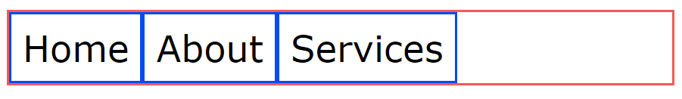

## **MARGINS**

|  |  |
| --- | --- |
| .services {  margin-left: auto;  } | Services  About  Home |
| //* Complete this code: */  .about,services{    margin-left: auto;  } |  |

## **FLEX**

|  |  |
| --- | --- |
| .container > div {    flex: 1;  } |  |
| .home, .about {    flex: 1;  }  .services {    flex: 2;  } |  |
| .home {    flex: 1;  }  .about {    flex: 2;  }  .services {    flex: 3;  } |  |
| .container > div {    flex-basis: 300px;  }  .about {    flex-shrink: 0;  } |  |
| .container > div {    flex-basis: 300px;  }  .about {    flex-grow: 1;  } |  |
| .container > div {    flex-basis: 200px;  }  .about {    flex-grow: 1;  }  .services {    flex-grow: 2;  } |  |

## **ALIGN SELF**

|  |  |
| --- | --- |
| .container {    height: 200px;    align-items: center;  }  .about {    align-self: flex-start;  } |  |
| .container {    height: 200px;    align-items: center;  }  //* Complete this code: */  .container {    height: 200px;    align-items: center;  }  .home{    align-self: flex-start;  }  .about{    align-self: flex-end;  } |  |

## **WRAP**

|  |  |
| --- | --- |
| .container {    flex-wrap: wrap;  }  .container > div {  width: 500px;  } |  |
| container {    flex-wrap: nowrap;  }  .container > div {  width: 500px;  } |  |